Project Design Phase - II Data Flow Diagram & User Stories

|  |  |
| --- | --- |
| Date | 17 October 2022 |
| Team ID | PNT2022TMID12755 |
| Project Name | Signs With Smart Connectivity For Better Road Safety |
| Maximum Marks | 4 Marks |

# Data Flow Diagrams:

A Data Flow Diagram (DFD) is a traditional visual representation of the information ﬂows within a system. A neat and clear DFD can depict the right amount of the system requirement graphically. It shows how data enters and leaves the system, what changes theinformation, and where data is

stored.

# Data Flow Diagram- Signs with smart connectivity for better road safety:

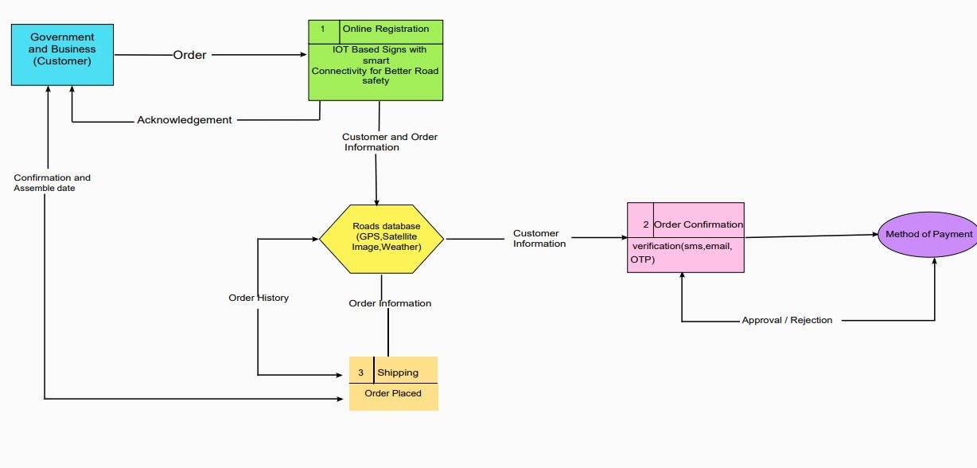

**User Stories**

Use the below template to list all the user stories for the product.

|  |  |  |  |  |  |  |
| --- | --- | --- | --- | --- | --- | --- |
| **User Type** | **Functional**  **Requirement (Epic)** | **User**  **Story Number** | **User Story / Task** | **Acceptance**  **criteria** | **Priority** | **Release** |
| Customer  (Mobile user) | Registration | USN-1 | As a user, I can register for the  application by entering my email, password, and conﬁrming my password. | Access my  account / dashboard | High | Sprint-1 |
| Weather | openweathermap | USN-2 | As a user, I want to check the  weather of that location | Get the weather  of that location | High | Sprint-1 |
| IoT devices | Automation | USN-3 | As a user, I want to use IoT  devices for automation  purposes | Get the work  done without  manual effort | High | Sprint-2 |
| Python code | Random data | USN-4 | As a user, I want to give some input to the devices for performing some action to  complete the tasks very easily | Get the data  workﬂow | Medium | Sprint-1 |
| IBM Cloud | Cloud services | USN-5 | As a user, I want to deploy  these application for public version | Useful for all  domain users | High | Sprint-1 |
| Node-Red | Integration | USN-6 | As a user, I want to integrate  the applications with hardware | To precise for  linear workﬂow | Medium | Sprint-3 |
| Web UI | Interaction | USN-7 | As a user, I want to interact  with the digital products | To interact with  the users | Medium | Sprint-2 |

|  |  |  |  |  |  |  |
| --- | --- | --- | --- | --- | --- | --- |
| Data  validation | Checking  accuracy | USN-8 | As a user, I can check the  ability and accuracy of the model in obtaining the required information | Check the  capability of the model | High | Sprint-2 |
| Data extraction | Obtaining the data | USN-9 | As a user, I can retrieve the result data from the application for data storage  for further uses | Download the result in the form of data | High | Sprint-3 |